For the first step, we were required to access Codio and create, show, and use our first database. The ‘create database Pirrone;’ command that I input into the terminal created a new database using MySQL. I was then able to view that database by entering the command ‘show database;’. This command would have shown me all the databases that I have created or have access to. Finally, I entered the command ‘use Pirrone;’ to access the database that I had just created and enter a mode where I can edit and alter that specific database.

The next task that I had was to create a table in the Pirrone database, show that table, and then describe that table. By entering the command ‘create table tb2 (user_id VARCHAR(50));’ into the console, I created a new table called tb2 and gave it a field with a defined character limit. I was able to show all tables in the Pirrone database by entering ‘show tables;’. When I entered ‘describe tb2;’, I was given tb2 to view and it showed me the parameters of that table.

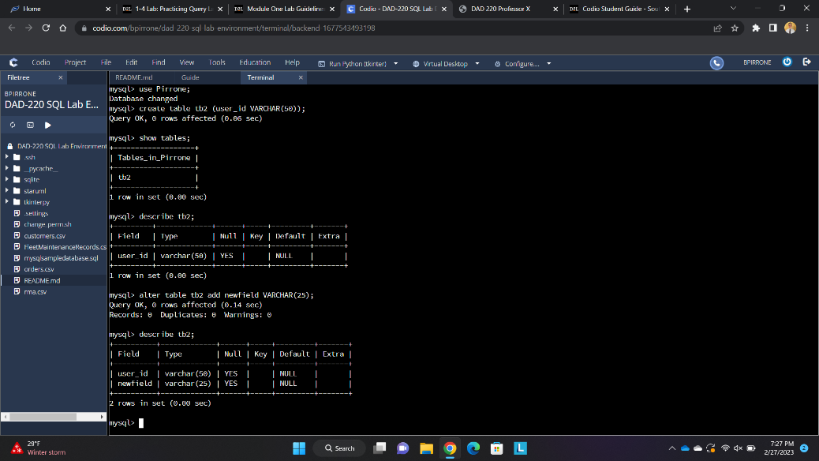

Lastly, I altered tb2 and then viewed my alterations. By entering the command ‘alter table tb2 add newfield(VARCHAR(25));’, I was able to add another field with a separate character limit. I then entered ‘describe tb2;’ and I was shown my new altered table.